A note on trying to extend the intermediate value theorem

First, it is necessary to introduce the following definitions,
- The function is said to be increasing at $x_{0}$ if for all $x$-values in some interval about $x_{0}$ it is true that when $x_{0}<x$ then $y_{0}<y$, and when $x_{0}>x$ then $y_{0}>y$.
- The function is said to be decreasing at $x_{0}$ if for all $x$-val ues in some interval about $x_{0}$ it is true that when $x_{0}<x$ then $y_{0}>y$, and when $x_{0}>x$ then $y_{0}<y$.
Then the definition of “a function is non-decreasing at $x_{0}$” is introduced by extend the definition of increasing above.
- The function is said to be non-decreasing at $x_{0}$ if for all $x$-values in some interval about $x_{0}$ it is true that when $x_{0}<x$ then $y_{0}≤y$, and when $x_{0}>x$ then $y_{0}≥y$.
The intermediate value theorem states:
If $f$ is a continuous function on a closed interval $[a,b]$, and if $y_{0}$ is any value strictly between $f(a)$ and $f(b)$, that is $min\{f(a),f(b)\}<y_{0}<max\{f(a),f(b)\}$, then $y_{0}=f(c)$ for some $c$ in $(a,b)$.
My original conjecture was to extend it to:
If $f$ is a continuous function on a closed interval $[a,b]$ with $f(a)<f(b)$, and if $y_{0}$ is any value strictly between $f(a)$ and $f(b)$, that is $f(a)<y_{0}<f(b)$, then $y_{0}=f(c)$ for some $c$ in $(a,b)$ and $f$ is non-decreasing at the $c$.
But it was said that the Weierstrass function, as a counterexample, is indeed nowhere monotonic, while I still couldn’t understand that. After reading the following proof for the intermediate value theorem,
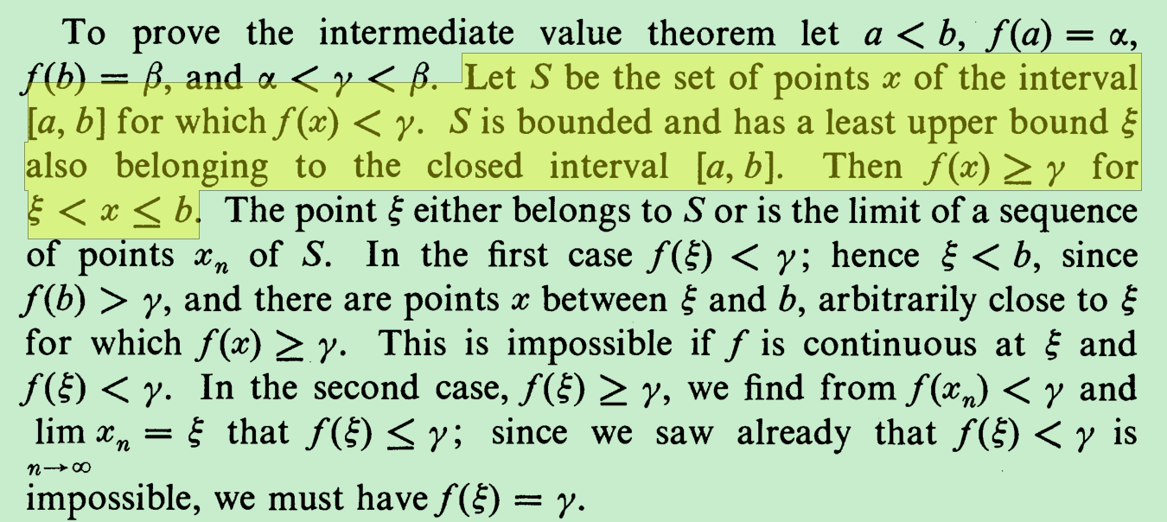
I realized I could save the conjecture to:
If $f$ is a continuous function on a closed interval $[a,b]$ with $f(a)<f(b)$, and if $y_{0}$ is any value strictly between $f(a)$ and $f(b)$, that is $f(a)<y_{0}<f(b)$, then there is a $c=sup(\{x∣f(x)<y_{0}$ in $(a,b)\}$) in $(a,b)$cause $y_{0}=f(c)$, and such that
- in every left neighborhood of $c$, there is always a $x'$ such that $f(x')<y_{0}$.
- for each $x$ in any right neighborhood of $c, f(x)≥y_{0}$.

The following two functions, which are both differentiable and continuous in neighborhoods around 0, are helpful for my consideration about the question.
$$f\left(x\right)=\left\{\begin{aligned}x^{2}sin⁡\frac{1}{x}, &\text{if }x<0 \\ x^{2}, &\text{if }x≥0\end{aligned}\right.$$
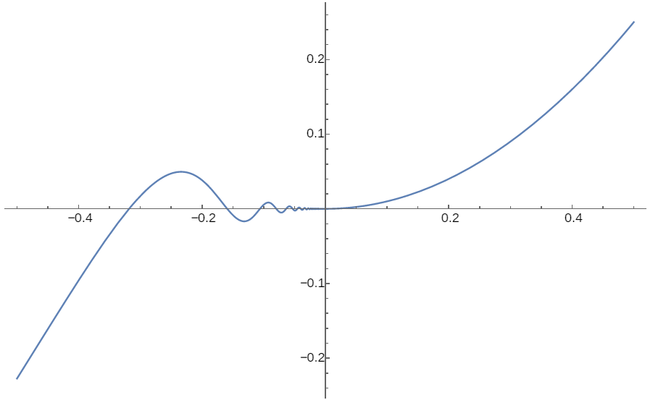

$$f\left(x\right)=\left\{\begin{aligned}-x^{2}, &\text{if }x≤0 \\ x^{2}sin⁡\frac{1}{x}, &\text{if }x>0\end{aligned}\right.$$
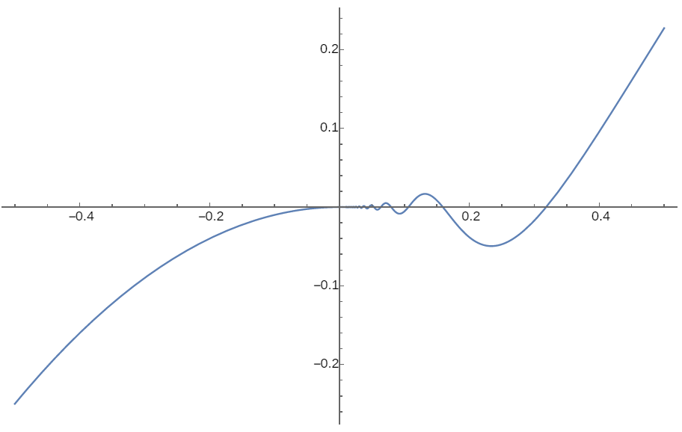

谷歌一下construction of nowhere monotone function

nowhere monotone functions and functions of nonmonotonic type jack b. brown, udayan b. darji, and eric p. larsen
https://www.ams.org/journals/proc/1999-127-01/S0002-9939-99-04571-2/S0002-9939-99-04571-2.pdf

The Cantor function O. Dovgosheya, O. Martiob,∗, V. Ryazanova, M. Vuorinenc
https://warwick.ac.uk/fac/sci/maths/people/staff/oleg_zaboronski/analysisiii/cantor.pdf

https://math.stackexchange.com/questions/879605/example-of-a-continuous-function-that-is-monotone-at-no-point

https://math.stackexchange.com/questions/622076/continuity-rightarrow-intermediate-value-property-why-is-the-opposite-not-tr/622083#622083

https://math.stackexchange.com/questions/42326/nowhere-monotonic-continuous-function

https://math.stackexchange.com/questions/802534/if-fx-0-for-all-x-in-mathbbq-is-f-constant/802647#802647

The Theory And Construction Of Non Differentiable Functions No I
https://archive.org/details/in.ernet.dli.2015.86355/page/n89/mode/2up

https://www.google.com/search?hl=en&q=nowhere%20monotone%20function

https://mathoverflow.net/questions/167323/everywhere-differentiable-function-that-is-nowhere-monotonic

https://math.stackexchange.com/questions/41902/is-this-condition-sufficient-to-ensure-monotonicity-of-a-function/41907#41907

Calculus: An Intuitive and Physical Approach, Second Edition, Morris Kline, Chapter 8，Section 3
Introduction to Calculus and Analysis Volume I, Reprint of the 1989 edition, Richard Courant, Fritz John, p101

